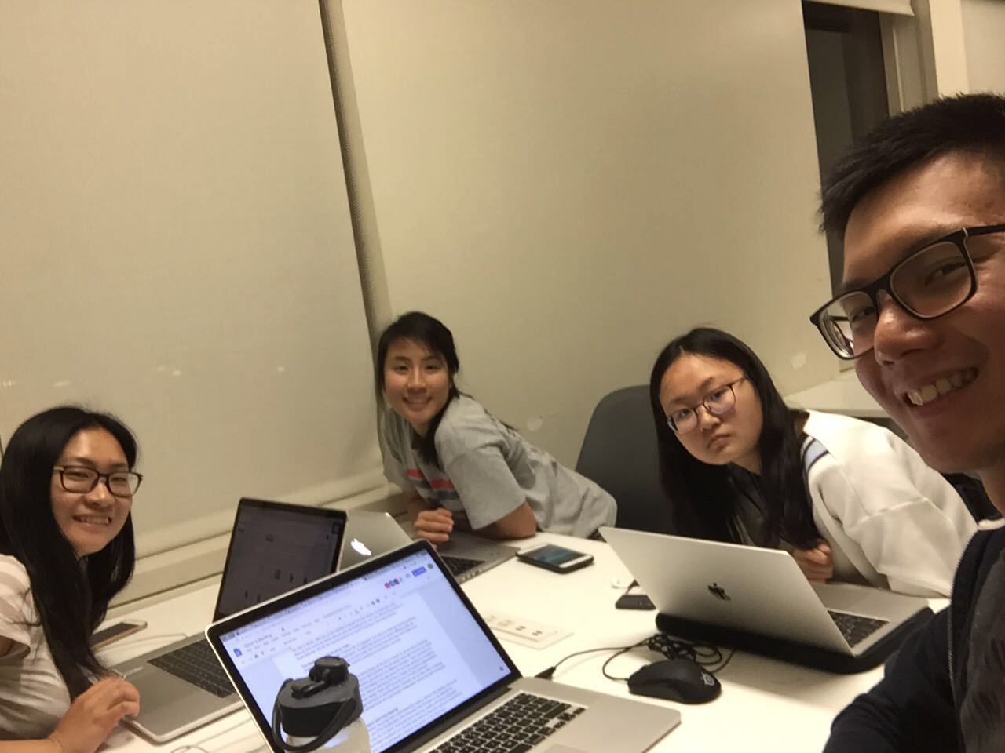

Allocated meeting time: April 9th, 8:30pm - 9:30pm

Actual meeting time: April 9th, 8:30pm - 9:30pm

Product owner: Professor Halfond, TAs, CPs

Scrum master: Gong Chen

Team members: Lingyi Li, Joann Lin, Peixuan Liu, Ryan To, Tuling Zhao

Scrum summary:

We refactored some part of our project and started working on writing test cases and implementing the requirements in our sprint 2 backlog.

1. What have you accomplished since the last meeting?
2. Are there any obstacles in the way of meeting your goal?
3. What will you accomplish before the next meeting?

Gong Chen:

1. Refactored the ServerTest written by Peixuan
2. None
3. Writing test for export

Lingyi Li:

1. I I added contents in sprint backlog and scrum meeting information in the sprint process report.
2. None
3. I will continue writing the deliverable

Joann Lin:

1. Worked on save collage and view saved collage functionality
2. Some questions about saved collages that I will ask CP about
3. Will continue to refine functionality

Peixuan Liu:

1. Refactored SaveServlet, SignUpServlet, MySQLDriver, LoginServlet and their black-box tests
2. None
3. Write tests for export functionality

Ryan To:

1. Finished the loading animation while the request gets sent to the backend for processing
2. None
3. Configuring HTTPS for our application

Absence reason: Conflicted group meeting

Tuling Zhao:

1. Wrote black box for collage generation, animation symbol and history gallery
2. None
3. Will update test and main.jsp to include no filter option

Absence reason: have class from 7 to 9:50